Day 1:

**1.1:- DFA for odd number of 1’s and even number of 0’s.**

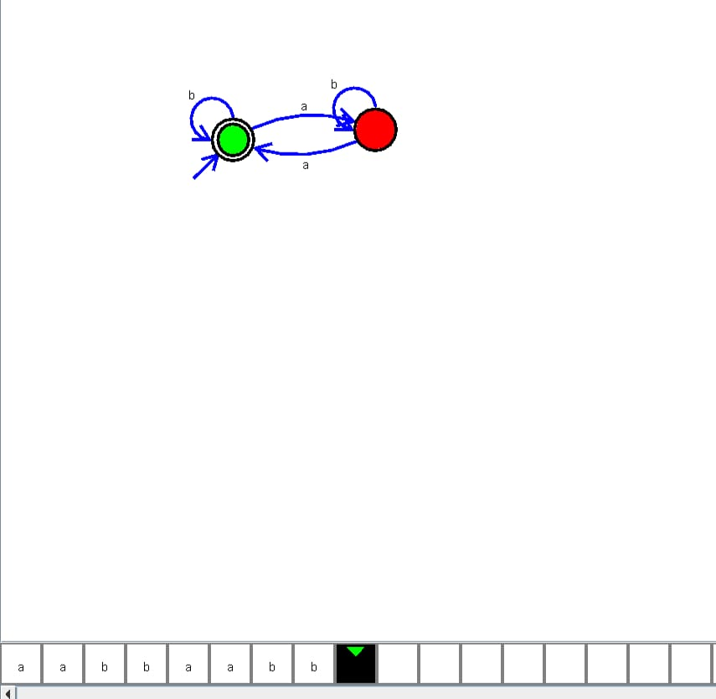

**1.2:-DFA FOR EVEN NUMBER OF 0’S AND EVEN NUMBER OF ONES.**

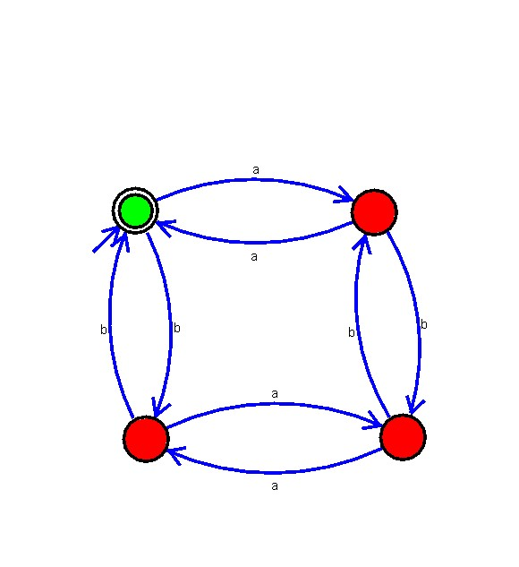

**1.3:-CONSTRUCT DFA HAVING SUBSTRING 101.**

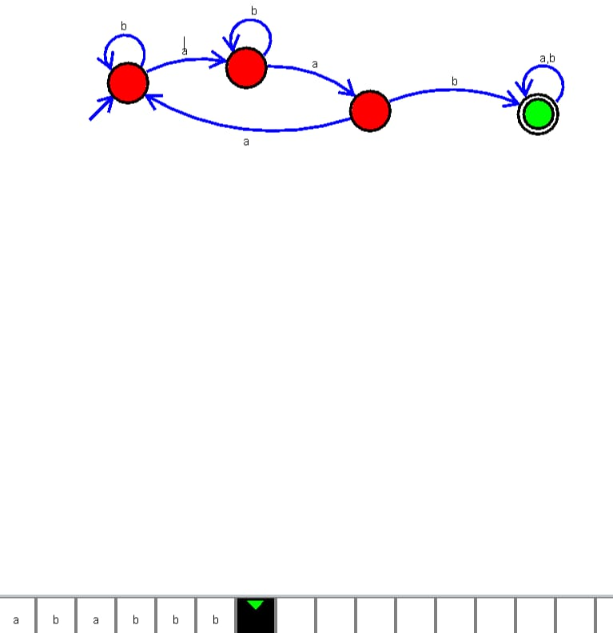

**1.4 CONSTRUCT DFA HAVING ‘NO’ CONSECUTIVE 0’S.**

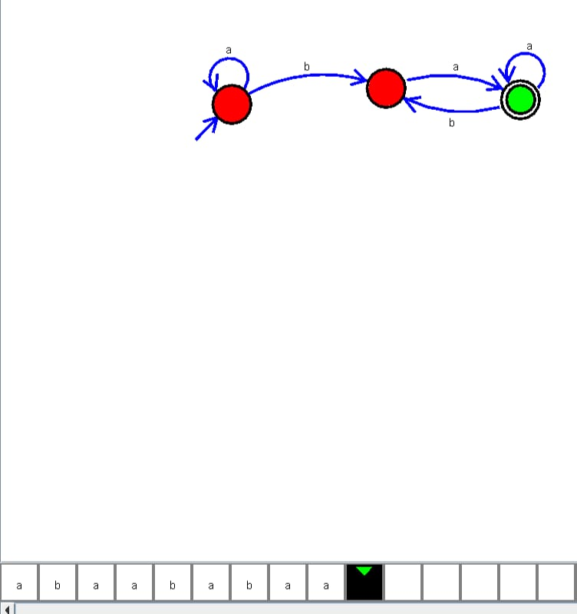

**1.5:- CONSTRUCT NFA BINARY STRINGS HAVING 00 AS SUBSTRING.**

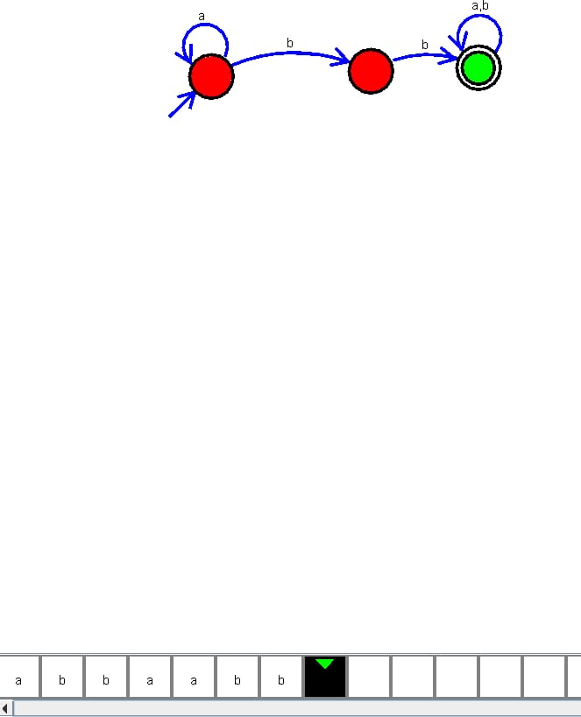

**1.6:-CONSTRUCT NFA START AND END WITH 0.**

